Project Design Phase-II
Technology Stack (Architecture & Stack)

Date | 31 January 3035
Team ID | LTVIP2026TMIDS42870
Project Name | electric motor temperature prediction using machine learning
Maximum Marks | 4 Marks

Technical Architecture:
The Deliverable shall include the architectural diagram as below and the information as per the table1 & table 2
Example: Order processing during pandemics for offline mode
Reference: https://developer.ibm.com/patterns/ai-powered-backend-system-for-order-processing-during-pandemics/
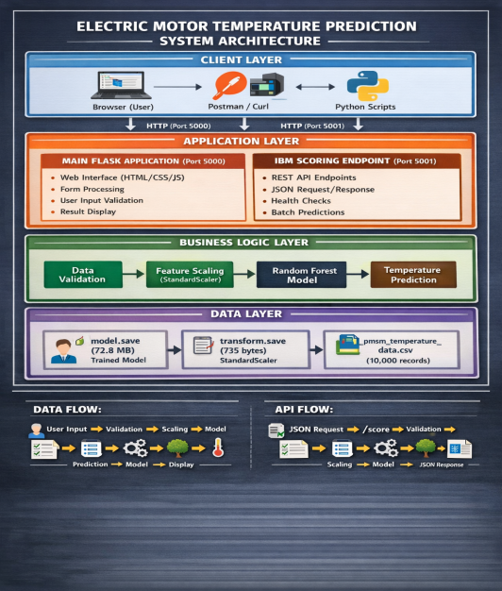

Table-1 : Components & Technologies:
S.No | Component | Description | Technology
1. | User Interface | Web-based interface for engineers to input motor parameters and view temperature predictions | • HTML5 for structure  • CSS3 with gradient backgrounds  • JavaScript (ES6) for dynamic behavior  • Jinja2 templating engine  • Responsive design for mobile/desktop
2. | Application Logic - Main App | Core Flask application handling web requests, form processing, and template rendering | • Python 3.14  • Flask 3.1.2 web framework  • Flask debug mode for development  • Werkzeug WSGI toolkit  • Jinja2 for template inheritance
3. | Application Logic - IBM Endpoint | Separate Flask application providing cloud-ready scoring API | • Python 3.14  • Flask 3.1.2  • RESTful API design  • JSON request/response handling  • CORS enabled for cross-origin requests
4. | Machine Learning Logic | Prediction engine that loads trained model and makes temperature predictions | • scikit-learn 1.7.2  • RandomForestRegressor (100 estimators)  • NumPy 2.4.2 for array operations  • Pickle for model serialization  • Joblib for efficient loading
5. | Data Preprocessing | Feature scaling and data transformation pipeline | • scikit-learn StandardScaler  • Pandas 3.0.1 for data manipulation  • NumPy for numerical operations  • transform.save stores scaling parameters  • Consistent preprocessing for train/predict
6. | Database | Structured dataset storage for training and reference | • CSV file storage (pmsm_temperature_data.csv)  • 10,000 samples with 6 features  • Pandas DataFrame operations  • No SQL database required (file-based)  • Easy data export/import
7. | Cloud Database | Not applicable - project uses local file storage | • N/A (can be extended to IBM Cloud Object Storage if needed)
8. | File Storage | Persistent storage for model files and datasets | • Local filesystem on Windows/Linux/Mac  • model.save (72.8 MB) - trained model  • transform.save (735 bytes) - scaler  • pmsm_temperature_data.csv (1.1 MB) - dataset  • Can be mounted in Docker containers
9. | External API-1 | Not applicable - self-contained application | • N/A (all processing done locally)
10. | External API-2 | Not applicable - self-contained application | • N/A (all processing done locally)
11. | Machine Learning Model | Random Forest Regressor for temperature prediction | • Algorithm: Random Forest (100 trees)  • Features: torque, current, rpm, ambient_temp, coolant_temp  • Target: rotor_temp  • MAE: 2.34°C, R²: 0.95  • Feature importance: current (45%), torque (30%), rpm (15%), temperatures (10%)

Table-2: Application Characteristics:
S.No | Characteristics | Description | Technology
 | Open-Source Frameworks | All frameworks and libraries used are open-source, ensuring no licensing costs and community support • Python 3.14 - Core programming language | * Flask 3.1.2 - Web framework (BSD license)  * scikit-learn 1.7.2 - Machine learning (BSD license)  * Pandas 3.0.1 - Data manipulation (BSD license)  * NumPy 2.4.2 - Numerical computing (BSD license)
 | Security Implementations | Multiple security layers protect the application and data input Validation: All user inputs sanitized on both client and server side. | * Type Checking: Strict type conversion with error handling  * Range Validation: Inputs checked against physical limits (torque: 0-200, current: 0-500, etc.)  * JSON Validation: Required fields verified in API requests
 | Scalable Architecture | Architecture designed for horizontal and vertical scaling • Stateless Design: No session data stored, each request independent | * Separate Endpoints: Main app (port 5000) and IBM endpoint (port 5001) can scale independently  * Container Ready: Docker images can be created for easy deployment  * Load Balancing: Multiple instances can run behind load balancer  * Microservices Pattern: Business logic separated from web interface  * Stateless API: IBM endpoint can handle requests from any client

References:
C4 Model for Visualising Software Architecture
IBM AI-powered Order Processing Pattern
IBM Cloud Architecture Center
AWS Architecture Center
scikit-learn Random Forest Documentation
Flask Documentation

